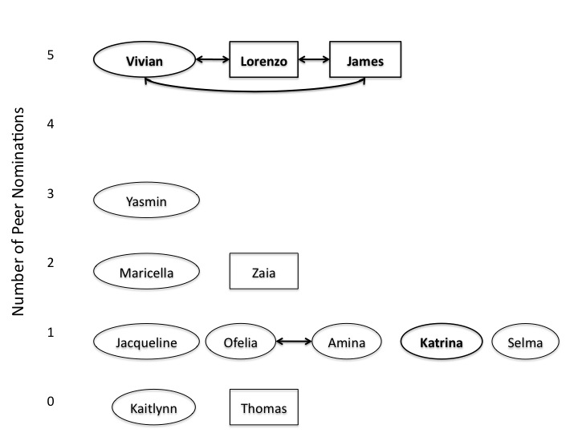
Figure 3: Simplified network of ideal partner nominations (bi-directional only)

